

US EPA

Smart City Air Challenge Submission

One Year Later—Aliso Canyon Gas Leak:

Restoring Residents’ Faith in Air Quality Utilizing Smart Sensor Technology

October 28, 2016

**Councilmember Mitchell Englander**

200 N. Spring Street, Room 405, Los Angeles, CA 90012

(213) 473-7012

# Executive Summary

## Solution Context

October 23, 2016 marked the one-year anniversary of the beginning of the Aliso Canyon Gas Leak, the largest natural gas leak in US history. During a four-month period, 100,000 tonnes of methane spilled into the air of the San Fernando Valley from a gas field managed by SoCal Gas. Over 20,000 residents were forced to relocate, two schools were forced to close, thousands of residents endured negative health symptoms, and countless local businesses suffered devastating effects.  For 119 days, thousands of people were displaced - causing physical, emotional, psychological and environmental damage.

The City of Los Angeles’ 12th District neighborhood of Porter Ranch bore the brunt of the damage. Residents have suffered immense trauma in the aftermath of the public health crises. A key contributing factor was the lack of real-time measurement of air quality based on sensor systems. District residents have felt the impact of air quality public crises – as their representation on the Los Angeles City Council, we want to deploy a solution that will transparently communicate real-time air quality to citizens, while tracking long term patterns to ensure air quality compliance to state standards.

The public health crises was driven by an invisible killer that is difficult to sense. Unlike most other pollutants, methane is transparent, odorless, and imperceptible by human senses. Current data is derived from enormous air quality monitoring stations that are incredibly expensive, and have been around for decades. These stations are highly accurate in their measurement, but also limited in their radius – yet cities continue to use their measurements as representations of a much broader geographic area. Given their price and size, cities cannot afford to purchase or place the number of stations that is required to give accurate reports on a localized level. Local officials cannot properly handle another incident without their own source of information to streamline the process. The EPA has issued this challenge to address such gap in measurement, and to encourage the burgeoning development of sensors that are up to the task.

## About Councilman Mitchell Englander

During the crisis, Councilman Englander’s office received thousands of phone calls from residents who were uncertain of the health risks for their families and the relocation resources available. The office took an active role in alleviating the immediate needs of residents as they transitioned to temporary housing. The councilman also advocated on behalf of the community in conversations with SoCal Gas, demanding an open and transparent line of communication, while organizing the community to inform them of their rights, and addressing business and economic concerns. After the immediate crisis, the councilman took legislative action to hold SoCal Gas responsible for their actions, demanding an investigation of the leak and called for sweeping reforms of the oil and gas industry. Councilman Englander is committed to finding solutions to address wrongs of the past and prevent them in the future. Please watch to learn more about Councilman Englander’s role in addressing the [Aliso Canyon Gas Leak](https://www.youtube.com/watch?list=PLdSJXgMQFixDFUcQS5xnWHu_jcp9w5asa&time_continue=70&v=Rihj0tMyFoE).

## Solution Strategy

The 12th District Councilman’s Office proposes to take action on 12th District concerns regarding air quality by measuring localized, real-time quantities of air using multiple sources of data that are aggregated through a data management platform. This data management platform can support hundreds of sensors from multiple vendors using different technologies and protocols – it will normalize each data source to a single language and expose the data through an API that is consumable by analytics and user interfaces. The deployment of this platform will also avoid siloes that lead to costly integrative efforts, through a single cohesive management system. This solution is scalable across the air quality domain, as well as other smart city verticals. The District plans to use these measurements to both track air quality on a hyper-localized basis to avoid an Aliso Canyon Gas Leak scenario again, as well as engage with the community by transparently having the information available for their data and visual consumption. The solution can build out beyond initial deployment in phases, as benefits are realized and the smart city infrastructure expands.

In the first phase, the City intends to begin by deploying a pilot of highly-calibrated cellular sensor hubs that each have multiple sensors. The cellular sensors procured for this solution will provide hyper-localized, high resolution up to 10m measurements of the specific areas they are deployed in. The sensors will be supplemented by an open-data software platform that aggregates local air quality station data and uses a predictive algorithm to tie that data with weather inputs to provide a high resolution calculation on air quality across a wide geographical spread. This algorithm provides 500m higher resolution and much higher accuracy than what air quality stations can provide on their own. It will provide a broad view of problem areas in a 10 mile radius near the Aliso Canyon Facility that may not be visible through current data measurements today. All data inputs, regardless of source, will be supported by the data management platform and normalized for consumption into a single environmental API that will be visualized by a UI with advanced data visualization tools running via a web browser. The application can display live data, historic graphs, histograms, tile maps and heat-maps of the area being covered. The API will also be available to the 12th District’s residents - citizens will be encouraged to access, and develop analytics and visualizations based on the collected data. This solution will fill the need residents have to trust their environment again.

With the smart city infrastructure in place to support expansion initiatives, the City can build out the solution beyond the initial pilot proposed for this solution. Air Quality is a key concern for the residents of the City, and expansion of the hyper-localized solution in the initial pilot will generate resident interest for citizens who want the same visibility in their neighborhood. In the next phase, additional sources of inputs could include odor meter and air quality sensors to measure the quantitative exposure to chemicals experienced by residents in neighborhoods near landfills. These sensors, when integrated with the digital platform, will be aggregated and normalized through the same existing infrastructure. The data will be visualized on the same applications, and be accessible by the public through the API.

The digital platform will support multiple smart city initiatives outside of air quality – for example, lighting, parking, and traffic solutions connecting the city’s infrastructure can all be managed by this single platform. This holistic perspective enables a cohesive infrastructure that maximizes efficiency, while limiting duplicative investments. With multiple smart city solutions spanning many domains, the 12th District could enable real-time cross-domain actions with the platform to drive actionable value by influencing traffic, parking, and other city solutions based on its environment solution. A potential use case could be that when gas concentrations reach a certain level, traffic is diverted in real-time from the area using the city traffic signal controls enabled on the same single platform.

## Target Deployment Areas

In the initial pilot, six of the cellular-based sensors will be placed around the Porter Ranch neighborhood in a stretch of about 1.5 miles. Please reference the below figure – the neighborhood sits within the area boxed in by red lines. The area is located south of the foothills where the Aliso Canyon Facility is located on Oat Mountain, and just north of the 118 Ronald Reagan Freeway. This geographic placement creates a persistent high-exposure environment for residents. The placement of these sensors will measure the invisible problems residents face every day in that environment. Dense sensor placement in an identified problem area will lead to a high-resolution quantitative measurement of air quality that citizens can track and observe for themselves, to re-establish trust in their own environment, as well as maintain their safety.

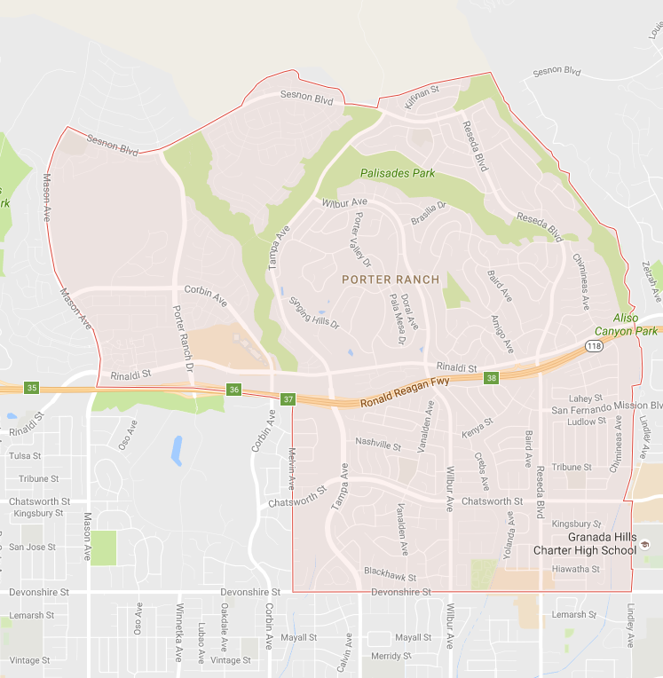

To supplement the deployed sensors, BreezoMeter will provide an AQI measurement across 10 sq miles of the geographic region based on a predictive algorithm operating on aggregated data from air quality stations already deployed. In addition, this software algorithm will provide daily forecasts with highly actionable data that can be used to identify problem areas for the city. BreezoMeter will provide the 12th District with a powerful monthly city report that will indicate air quality problem areas, and which pollutants need to be measured on a higher resolution with sensor deployments in a given area. This report will give the district direction in building out the air quality solution.

# Method and Technology

The below architecture depicts each layer of the solution.

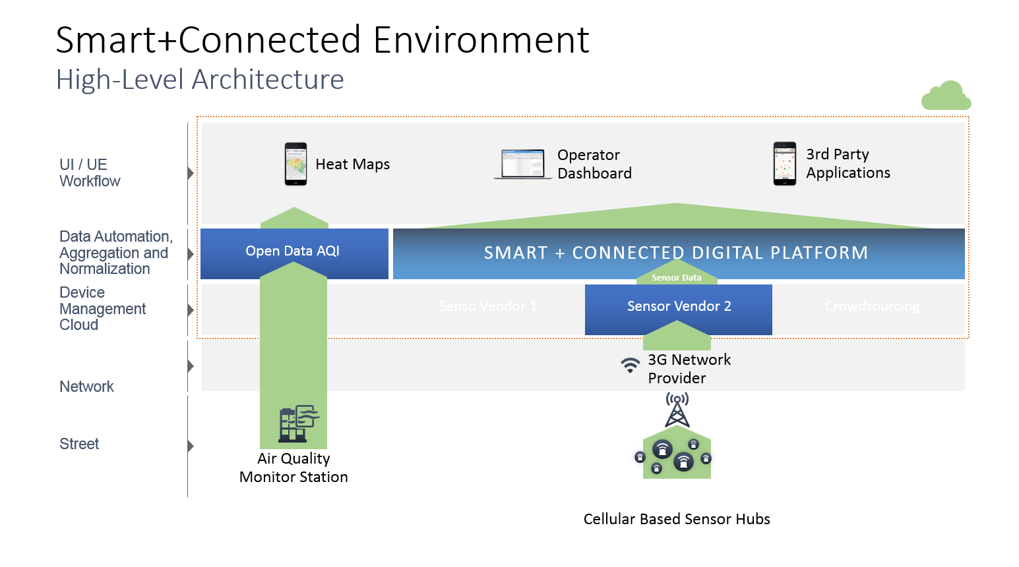

## Leapcraft CPH Sense Nodes:

Sensors must be small, easy to install, highly accurate, inexpensive and perform well against traditional air quality stations to be worth the investment by the City. There are multitudes of low-cost gaseous sensors on the market today, but none actually achieve the levels of accuracy and calibration to make the data being collected reliable. Conversely, the sensors used by air quality stations range in the hundreds of thousands of dollars – this level of expense for a city is unrealistic to fund for the dense placement required for hyper-localized data. The district deployed a pilot of an air quality sensor in the wake of the crisis, but it was found to be ineffective due to its obtrusive size and lack of mobility. Sensors must be strike the right note of size and price while maintaining their accuracy integrity.

Leapcraft Aps., is a start-up based out of Denmark that fits the above criteria. They develop the CPH Sense nodes that the councilman’s office will procure for the purposes of this pilot. These “sensor hubs” come fully calibrated to measure certified gases that specifically lead to adverse effects to human health. The nodes will include four gas sensors, three particulate sensors, and two environment sensors (temperature and humidity). All sensors are highly accurate and perform strongly in air quality benchmarks in Denmark, which have some of the highest air quality standards in the world. Post installation, CPH Sense runs real time compensations for drift and high sensing resolution via its cloud services, and receives nodes back for re-calibration in the Leapcraft lab as required.

Specs:

* IP54 rating - designed for air intake and water splash /rain protection.
* Hubs measure 15.5” by 4.3” by 4.1” (inches) and weigh 9lbs.
* Each node comes with 9 sensors included – CH4, NO2, NO, SO2, CO2, PM1, PM2.5, PM10, temperature (F), and humidity (Rh).
* Draw up to 5w of power and can be supported by any regular electric line.

The Councilman’s office will procure six of these nodes for the purposes of this pilot, for a total of 54 sensors to be deployed. While CPH Sense nodes are competitively priced for their value, a limited pilot to prove the value of densely placed sensors that measure air quality on the ground level is the best way to begin the investment. As the solution proves its value to the city government and residents, more sensors and solutions can be seamlessly added on to the solution by integrating with the data management platform that will be deployed as part of this solution. This will allow the City and citizens to develop their smart city infrastructure as benefits come in, and issues arise.

Installation of the nodes is straightforward and simple. The councilman will budget an electrical contractor to mount the nodes 10 ft off the ground on buildings, using existing wiring to power the nodes.

## BreezoMeter

BreezoMeter Inc. addresses the issue of current air quality station data inaccuracy by applying a predictive algorithm to the data that ties current weather patterns and other factors that calculate air quality given those factors across a dispersed area.

This algorithm takes factors such as weather, traffic, and other factors into account to provide an accurate prediction on what the AQI is in a given area, with a resolution up to 500m. They will provide a separate calculation on methane levels in the broader area, using the same algorithm. Their AQI provides powerful insights on population exposure on a broad scale throughout the city. This data input gives the broad perspective on air quality across the region, while the CPH Sense nodes provide a deep, vertical perspective on the air quality in specific areas. Together, the City will roll out a comprehensive air quality measurement set that will both broadly improve measurement with the software algorithm, and provide the hyper-localized perspective on where to expand and continue building the solution.

## Smart+Connected Digital Platform

This solution will collect large amounts of diverse data. City management involves many independent departments, external partners and vendors. The City has already made individual IoT investments, but the city ecosystem is fragmented. An infrastructure that reduces duplicative investments, supports current and future services, and streamlines management is necessary to maximize the efficiency and value of connectivity. The ability to support that data and share information, coordinate activities, and improve service delivery is essential. A data management platform providing a single federated data management layer across all verticals will avoid integrative costs while enable extensibility.

Cisco Inc. will provide the Smart+Connected Digital Platform. This platform enables multiple data inputs regardless of source or vendor to be aggregated and normalized in a single cohesive infrastructure to support the 12th Council District solution. Both CPH Sense nodes and BreezoMeter’s AQI inputs will be aggregated and normalized through the digital platform, and exposed through an API that will be publicly available, as well as feed into applications.

The data enters from the street-level sensors and network to vendor-managed device clouds. These clouds communicate with the digital platform through an extension that normalizes the sensor data into a single language. The data federates across various supporting engines to be exposed through a domain-based API that is consumable by applications sitting on top of the platform. These applications are connected through an extension that takes the normalized data and converts it to an app-usable form.

The digital platform is extensible across vendors and domains. It is a smart city infrastructure piece viewing city management through a holistic lens and seeking to break siloed management systems. It is highly scalable, and can support all smart city infrastructure for multiple verticals through one management system. The deployment of this platform will enable multiple air quality sensor deployments in the future.

## Application

Leapcraft’s CPH Sense user interface will be provided to residents as a visualization of both data inputs – sensors and BreezoMeter’s AQI, visualized as a heat map, on a publicly accessible browser.

The CPH Sense cloud interface has advanced data visualization tools running via a web browser. It can display live data, historic graphs, histograms, tile maps and heat-maps of the area being covered. In addition raw data is available for offline analysis via a data dump or REST-API.

The CDP Dashboard will also be available for fault management and system health review.

The City plans to make the API publicly accessible for analytics development, as well as consumable by applications citizens want to visualize their air quality data in.

This pilot will establish a strong foundation for air quality that will yield immediate analytical benefits. Next phases on the pilot are very achievable with data management platform that will be deployed with the pilot – it is extensible, scalable, replicable, and highly moldable to the city’s requirements.

# Background Evidence

The leak began on Oct 23, 2015. SoCal Gas failed to properly notify authorities of the leak occurrence. The gases spilled into the area for four days before agencies and officials were notified that concentrations in the air were much higher than normal. Other than the utility company’s own alert system, there was no infrastructure in place that could have alerted city government officials to the situation. SoCal Gas went under investigation for wrong doing, but the city and residents need their own monitoring system to re-establish faith in the air they breathe.

The California State Government enforced several safety measures on the facility in order to prevent such a delay in sensing the issues again. However, in terms of actually preventing an issue, few measures have been taken. The city can therefore assume they are in danger of this situation coming up again – and they need their own sensing system in place to minimize the damage, to avoid relying on the facility’s word.

Source: The LA Times: [Air Quality Impact](http://www.latimes.com/local/lanow/la-me-porter-ranch-settlement-20160913-snap-story.html)

The leak was a wake-up call for residents. The risk of the region’s dependency on natural gas is highlighted as a risk, and agencies are moving towards more sustainable sources of energy that do not pose such risks to residents. The region has been transformed by the event, and the environment, especially air quality is at the forefront of resident concern. Residents recognize the impact of air quality on an unprecedented level, and their investment in the success of air quality measuring solutions that they can trust is at an all-time high.

Source: The LA Times [One](http://www.latimes.com/opinion/editorials/la-ed-aliso-canyon-20161023-snap-story.html) Year Later

Upon recognition of the issue, residents were evacuated and SoCal Gas took the responsibility of cleaning their homes and areas – yet even upon return, hundreds of residents experience health issues such as nosebleeds, nausea, and dizziness. Even now, residents continue to feel the impact of the gas leak, with very few answers. The real-time air quality pilot will help alleviate resident concerns with their air quality, and their environment. Please read the below for stories on the natural gas leak’s impact of resident health.

Source: LA Daily News [Impact on Resident Health and the lack visibility on Air Quality](http://losangelesdailynews.ca.app.newsmemory.com/publink.php?shareid=0391bf7cf)

Please Review:

[Federal Interagency Task Force statement on Natural Gas Storage Safety regarding its findings on the causes and effects of the Aliso Canyon Gas Leak and the measures needed to prevent another disaster](http://energy.gov/fact-sheet-ensuring-safe-and-reliable-underground-natural-gas-storage)

# Constraints

1. **Deploy 250 to 500 sensors in a community**: Initially a pilot covering a 10 mile radius to kick off the air quality initiative, then procure and deploy sensors on a rolling basis.
2. **Community involvement in purchasing and using the sensors:** YES, the City of Los Angeles will procure and deploy the sensors.
3. **Identification of partners and project sustainability:** YES, project will include consortium of partners to provide each component.
4. **Be transparent in terms of making the data open and describing the data management plans:** The platform will provide data management, and the normalized API with all air quality data will be accessible to the public through an open-data platform.

# Appendix

**Data management** - 25%

1. **How will you manage the Data so it can be used?**

The data will be normalized, aggregated, and exposed through a single domain-based API – in this case, Environment – and be consumable for analytics and visualization.

1. **What data storage methods will you use?**

Our digital platform uses Hadoop based big data infrastructure with an option to encrypt the data while in storage.

1. **What metadata will you collect?**

We collect sensor read-outs from deployments, as well as AQI and heat map information from all data inputs. All pollutants being measured will come through, as well as weather sensors.

1. **What data transmission protocols will you follow**?

CPH Sense Nodes use 3G backhaul. Any protocols and network can be supported with the software data management platform.

1. **How will you make the data free public, free of charge, and machine readable?**

The UI will be publicly available through a simple web-browser.

The data will be normalized across vendor and technology and exposed as an API in TQL – things query language. With the simple development of an adaptor code using a sandbox kit and API documentation (will be available on Cisco DevNet by January 2017), any application developer can use the API and get key permission to consume the data with their application. The API will be posted in an open-data platform.

1. **How will you reduce the risk of Personally Identifiable Information (PII) to individuals and the community?**

The digital platform utilizes role-based access to ensure the proper credentials are required to access potentially sensitive information. These can be configured per the PII need.

**Data Use** - 25%

**1. What pollutants will the sensors sample?**

Methane, NO2, NO, CO, SO2, PM1, PM2.5, PM10, temperature (F), and humidity (Rh).

**2. How will you use the data?**

With measurable impact of air quality, the city can take long and short term action to reduce the air quality issues in the area.

Develop a baseline to improve off of.

Establish neighborhood organizations to highlight the availability of data.

**3. How will the community save money or reduce costs by the use of the air quality data?**

By taking actionable insights, the community will provide a tremendous social good to the community that will reduce air quality related health care issues. In addition, long-term patterns can indicate what urban planning changes might need to be taken, reducing the cost of developing smart city solutions by providing consultation and perspective on direction from the beginning.

**4. What problems do you plan to address with the data?**

We will address the gap in the lack of reliable, accurate real-time air quality in the Porter Ranch neighborhood. We will begin data collection of the accuracy type that can truly inform and drive initiatives for improvement.

We will alleviate resident’s concerns regarding air quality, and empower resident’s confidence in their ability to view their current air quality.

We will ensure corporate accountability and remove reliance on their notification by deploying our own system.

We intend to understand how the urban environment’s shape currently affects air quality, and use it as part of a long-term tracking on meeting emissions level agreements, as well as inform urban policy and planning.

**5. How will you analyze and visualize the data?**

Once data is aggregated and normalized through the Smart+Connected Digital Platform, which enables multiple sources of data to be accessible through a single API. Applications then access the API to consume the data and run analytics for visualization purposes.

The CPH Sense cloud interface has advanced data visualization tools running via a web browser. It can display live data, historic graphs, histograms, tile maps and heatmaps of the area being covered. In addition raw data is available for offline analysis via a data dump or REST-API.

The CDP Dashboard can display fault management of the system, to ensure maintenance is fully covered.

We will provide the API for use in an open data platform available to the public to develop UI and analytics off of – the open system will allow them to get access to multiple sources of data and develop applications and readings of the data that suits their interests.

Any future application the District chooses to deploy in the city can consume data from the normalized API as well.

**6. Who will use the data?**

The residents of 12th District will use the data to stay updated on their neighborhood, replenishing their peace of mind. The councilman will sponsor initiatives on developing analytics around using the data.

**Sensor Procurement and Deployment** - 25%

**1. What sensors will you procure and how will you select them?**

We will procure Leapcraft CPH Sense Nodes. The nodes include 9 sensors that measure air quality through samples taken at set intervals. We have selected the sensor options from Leapcraft based on the use cases we envision accurate air quality measurement to enable.

We selected Leapcraft Air Quality Nodes on the basis of their accuracy and design. The nodes were benchmarked against the European Commission’s standards and reached 95% accuracy.  
**2. How will you procure the sensors?**

The councilman’s office will use part of its award money to procure the sensor nodes directly from the sensor manufacturer.  **3. On what basis will you deploy the sensors?**

One of the partners involved in the solution, BreezoMeter, will include consultation services in conjunction with the district. They will provide a city report isolating problem areas that were not visible prior to their deployment. Their software algorithm can visualize AQI of the broader 12th district area, and isolate areas with problematic AQI patterns. The district will focus on deploying the further sensors in those areas for hyper-localized air quality measurements to get a deeper, higher resolution on real-time air quality*.*   
**4. How will you track the sensors in order to know if they are operational?**

The Sensors send a heartbeat signal at regular frequency and the cloud service can notify an individual by email in case of errors or no data.

In addition, we will have a dashboard visualization of the sensors that will include fault management by giving alerts.  
**5. How will you ensure the physical security, accuracy and precision of the sensors both initially and over time?**

The CPH Sense hardware is ruggedized for harsh outdoor exposure and has a mounting option via a metal bracket with security screws. The device by itself is typically mounted at 3.5-4.0 meters above ground to avoid vandalism and still be within breathable street level. The device is calibrated before deployment with certified gases and zero air. The linearity and characterization of the sensors have been established by lab tests and the same protocol will be followed.

Over time, long term drift is factored in by running a compensation for temperature and humidity shifts over time. If there is a noticeable anomaly, a re-calibration will be conducted by shipping the device back to the sensor company. We can do a site-specific calibration by using borrowed reference instruments on a van next to the sensor location with a reasonable frequency.  
6. **How quickly can you get the project into operation (faster is better)?**

We can get the project into operation by Spring 2017.

**Project Sustainability** - 25%

**1. How will you invest resources (e.g., funds, staff time) by the community and by individuals who will use the sensors?**

The Councilman’s office will establish an outreach program to residents and business that were displaced in the affected communities. The councilman’s office will work on the program management aspect of pilot deployment.

**2. What partnerships will you establish to implement the project, e.g., with sensor manufacturers, data management organizations, environmental groups, etc.?**

We will establish partnerships with market leaders in the Smart City vertical. Cisco will provide a city data management platform with broad data management and cutting edge security, BreezoMeter will provide a broad software algorithm on the and Leapcraft will provide highly accurate sensors in our pilot. We will also partner with local initiatives to drive value from the solution – we will work to get data from existing sensors  **3. Is the proposed approach economically viable and replicable?**

The focus of this approach is highly scalable. We are beginning with a limited pilot of sensors that is supplemented with a software reading of the area that provides a broader perspective on air quality. Many other cities can begin at a similar scale and grow their solution as benefits and public support roll in.

In addition, with the implementation of the Smart+Connected Digital Platform, current and future solutions can be supported. Cities now have a platform to avoid painful, costly integrative approaches, as well as the freedom to procure whatever sensors best fit their needs. It is a pay-as-you-grow model – as city budgets and focus permit, residents can take initiative without needing to make a gargantuan upfront investment, as well  
**4. What are the possible barriers to success and how will you overcome them?**

Possible barriers include certification of Leapcraft nodes for operation in the USA, and lack of public interest in the API. We will overcome them by tracking certification of the nodes, and choosing nodes with a similar profile if certification is not achieved in time to support the project.

We will develop outreach projects to the community where the pilot is deployed to maximize public interest.   
**5. Do team members have the relevant expertise and resources available to carry out proposed work?**

Yes. Each team member brings extensive experience and passion in air quality management in cities. Please see the below profiles, as well as the letters of support from our partners.

|  |  |  |  |
| --- | --- | --- | --- |
| **Partner** | **Cost Distribution** | **Reference Points of Contact** | **Experience** |
| City of Los Angeles, the 12th District | 6K | Mitchell Englander  councilmember.englander@lacity.org Councilman, the 12th District, City of Los Angeles | Councilmember Mitchell Englander was elected to serve as Los Angeles City Councilmember for the Twelfth District on March 8, 2011, to serve the communities of Granada Hills, Northridge, Porter Ranch, Chatsworth, North Hills, Reseda, Sherwood Forest and West Hills. He is currently serving as the President pro tempore of the Council. He serves as Chair of the Public Safety Committee, Vice-Chair of the Budget and Finance Committee, and is a member of the Planning and Land Use Management Committee and the Executive Employee Relations Committee. |
| Leapcraft Aps | 18k | Vinay Venkatraman  vv@leapcraft.dk  CEO, Leapcraft ApS. | Designer & Serial entrepreneur with experience of developing several IOT products and sensor devices for Air quality, medical devices and industrial applications for the last 10 years. |
| BreezoMeter Inc. | 10k | Ziv Lautman  [zivl@breezometer.com](mailto:zivl@breezometer.com)  Chief Marketing Officer | B.Sc. Environmental Engineering (Summa Cum Laude, Technion). Milken Institute Fellow Alumni who worked with decision makers at Israel’s Ministry of Environmental Protection. |
| Cisco | 6k | Munish Khetrapal  [mkhetrap@cisco.com](mailto:mkhetrap@cisco.com)  Managing Director, Smart Cities and IoT | Developing Smart City Solutions for 5+ years. Enabled pilots with burgeoning capacity across Europe, Asia, and the Americas. |

**6. How is the project eco-friendly**?

The sensors themselves have minimal power requirements and will use existing power sources, thereby not impacting the urban landscape. The air quality measurements will lend themselves to eco-promoting initiatives across the city.

